**Types of Banks and services in the U.S**.

There are many types of banks in US banking systems

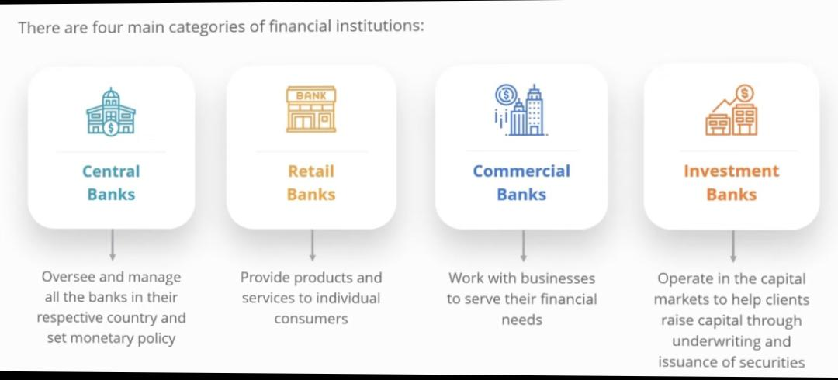

**Central Banks**

In terms of banks, the central bank is the head honcho. Central banks manage the money supply in a single country or a series of nations. They supervise commercial banks, set interest rates and control the flow of currency.

Central banks also implement a government’s monetary policy goals, whether that involves combating deflation or keeping prices from fluctuating. If necessary, they can lend money in rough economic times to keep the monetary system from collapsing. In the Unites States, the Federal Reserve System is the central bank. The European Central Bank regulates economic activity for the 28 countries in the eurozone.

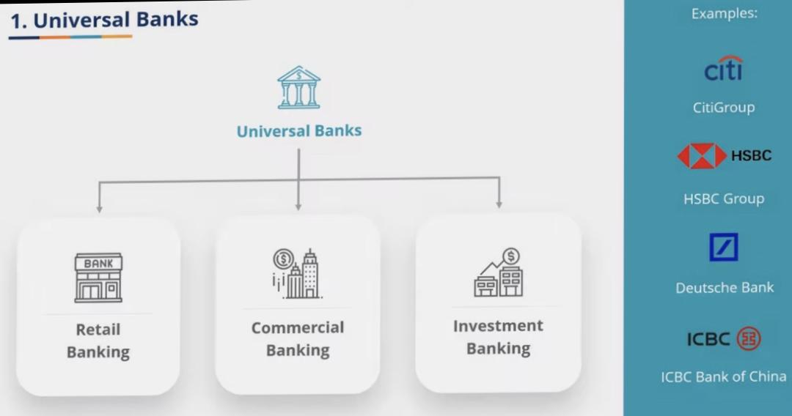

**Retail Banks**

The heart of retail banking is personal finance with the likes of you and us as the main customer. Most retail banking also promotes commercial banking.

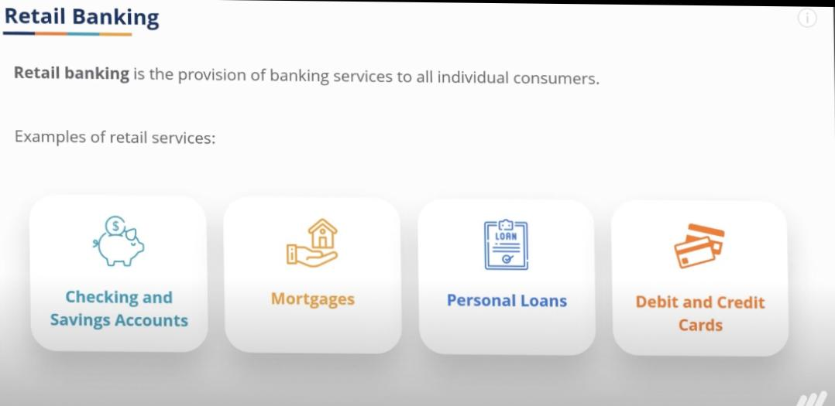

Retail Banking offers

* Checking and savings accounts
* Accepts deposits
* Lends money
* Issues credit and debit cards
* Performs foreign currency exchanges

And offers other basic financial products to individuals.

Examples: 1.standard chartered

2.Emirates NBD

3.Mashreq

**Commercial Bank**

Commercial banks focus on business needs

* They help businesses accept credit cards
* Types of payment from customers using point of sale device
* Online integrations
* Guidance on managing their assets while limiting risk
* Expanding their business overseas
* Borrowing money to expand operations

Examples: 1. Citibank

2. Barclays

**Let’s get into deep thought of commercial banks.**

**I would like to work on Citibank.**

Citibank, a significant entity in the U.S. banking system, offers a comprehensive range of services catering to diverse audiences. For individuals, it provides personal banking options such as checking and savings accounts, credit and debit cards, personal loans, mortgages, and robust online and mobile banking services. Wealth management services include investment advice, private banking for high-net-worth individuals, and trust and estate planning.

**Services**

For businesses, Citibank delivers tailored solutions for small and medium-sized enterprises (SMEs), including business accounts, loans, and merchant services. Large corporations benefit from corporate and investment banking services, treasury and trade solutions, and commercial real estate financing. Institutional clients enjoy advanced financial services like markets and securities trading, asset management, and custody services.

**Target audience**

Citibank’s target audience ranges from individual consumers and small business owners to large corporations and institutional investors. Additionally, its extensive international presence makes it a go-to for global customers requiring cross-border banking services. This broad spectrum of services and targeted approach underlines Citibank’s role as a versatile and influential player in the U.S. banking sector.

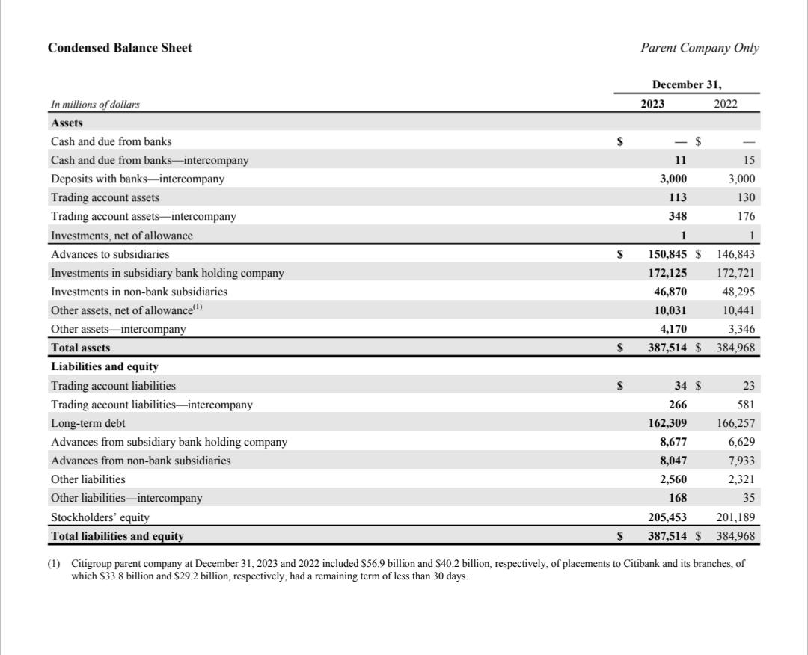

The balance sheet is one of the three core financial statements that are used to evaluate a business. According to above balance sheet we can say company performs well.

**Achievements in last two years**

Citibank has achieved significant milestones in the past two years. Here are some highlights:

Global Recognition: Citi was named Best Payments and Treasury Bank, Best Securities Services Bank, and Best Investment Bank in Emerging Markets by Euromoney in 2023.

Digital Leadership: They won awards for their digital customer experience, including World’s Best Transaction Bank for Digital CX from The Digital Banker in 2023.

Strong Private Banking: Citi Private Bank was recognized as Best for Ultra-High Net Worth in Asia and Hong Kong by Asiamoney, and World’s Best Private Bank for net worth of $25 million or more for 2024 by Global Finance Magazine.

**Investment Banks**

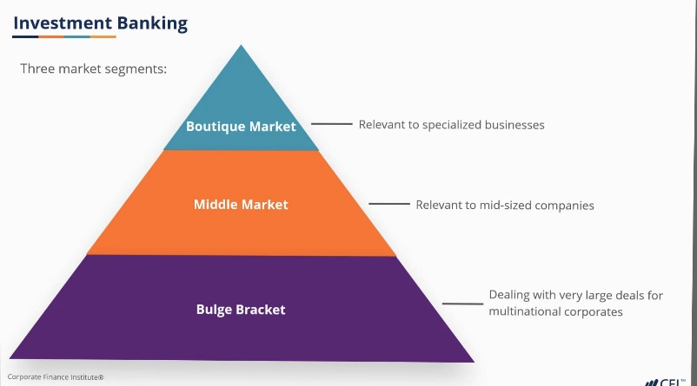Investment banks generally handle more complex financial transactions such as company mergers and acquisitions, issuing shares of stock when a company goes public. Acting as an advisor for companies performing financial research

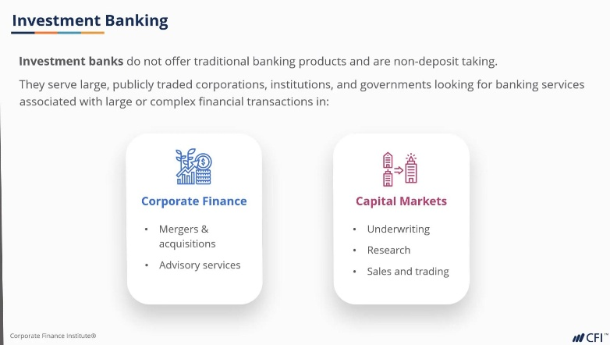Investment banks services are often broke into three market segments

**Online banks or Fintech startups**

They operate entirely online . There are no physical branch locations available to visit.

Many brick and mortar banks also offer online services. Such has the

* Ability to view accounts
* Pay Bills online
* Internet banks often
* Offer competitive rates on savings accounts
* Offer free checking accounts

Examples: 1. Liv

2.Finablr

**Cooperative Banks**

Cooperatives can be either retail banks or commercial banks. What distinguishes them from other entities in the financial system is the fact that they’re typically local or community-based associations whose members help determine how the business is operated. They’re run democratically and they offer loans and banks accounts, among other things. They’re popular in countries throughout the world and in the U.S. they usually take the form of credit unions.

Examples: 1. Navy federal credit union – credit union

2.GLS Bank

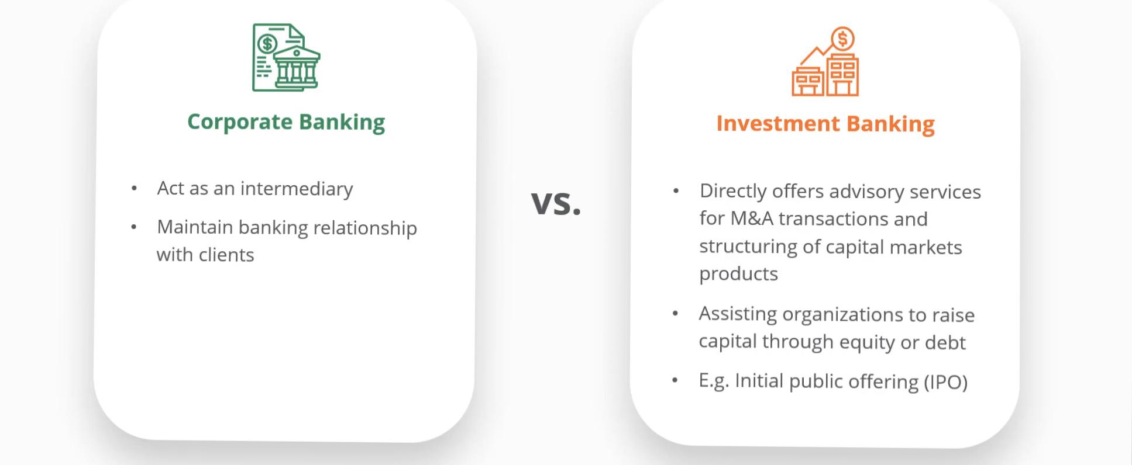 3.Shared intrest – co-operative Lending society

**Compare between investment banks services and cooperate banks services**.

**Why the U.S. Banking System Needs Different Types of Banks**

Different types of banks are essential in the U.S. banking system to address the diverse financial needs of individuals, businesses, and institutions. Retail banks and credit unions provide basic services like checking and savings accounts, loans, and credit cards, catering to everyday consumers. Commercial banks serve businesses with specialized services such as business loans, merchant services, and cash management. Investment banks offer critical services for corporations and institutional investors, including mergers and acquisitions advisory and underwriting.

**How they generate revenue :**

These banks generate revenue through various means: retail and commercial banks earn from interest on loans and fees for services, investment banks from advisory and underwriting fees, and private banks from management and advisory fees. Online banks and fintechs earn through transaction fees and interest from online loans.

**Contribution to economy**

Their contributions to the economy are significant. By providing loans, banks facilitate investments in homes, education, and business expansions, driving economic growth. They support businesses with essential financial services, enabling efficient operations and risk management. Additionally, banks play a crucial role in job creation, both directly as major employers and indirectly by enabling business growth and expansion. This diverse banking ecosystem ensures tailored financial solutions, fosters competition, and promotes economic stability and growth.

**Other well known banks**

* **Credit Unions**
* **Savings and Loan Associations**
* **Insurance companies ect**